POP ART

Origin
Pop art is an art movement that emerged in the mid-1950s in Britain and in the late 1950s in the United States. The origins of pop art in North America and Great Britain developed differently. In the United States, it marked a return to hard-edged composition and representational art as a response by artists using impersonal, ordinary reality, irony and parody to defuse the personal symbolism and "painterly looseness" of Abstract expressionism. By contrast, the origin in post-War Britain, while employing irony and parody, was more academic with a focus on the dynamic and paradoxical imagery of American popular culture as powerful, manipulative symbolic devices that were affecting whole patterns of life, while improving prosperity of a society. Early pop art in Britain was a matter of ideas fueled by American popular culture viewed from far, while the American artists were inspired by the experience of living within that culture. Similarly, pop art was both an extension and a rejection of Dadaism. While pop art and Dadaism explored some of the same subjects, pop art replaced the destructive, humorous, and revolutionary impulses of the Dada movement with detached affirmation of the artifacts of mass culture. Among those artists seen by some as producing work leading up to Pop art are Pablo Picasso, Marcel Duchamp, Kurt Schwitters, and Man Ray. Some of the work of Alex Katz anticipated Pop art.

Painting and Sculpture Examples
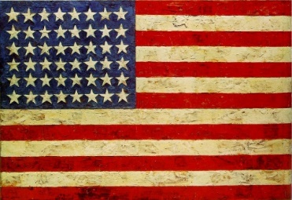 Jasper Johns, 1954–1955Flag

- Claes Oldenburg and Coosje van Bruggen, Typewriter Eraser, Scale X, 1999, painted stainless steel and fiberglas

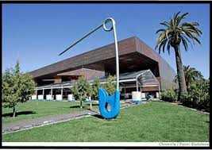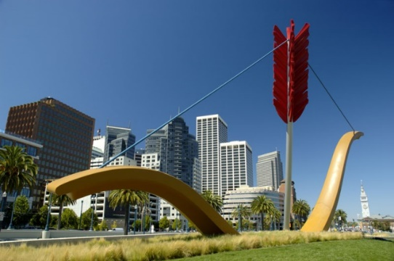
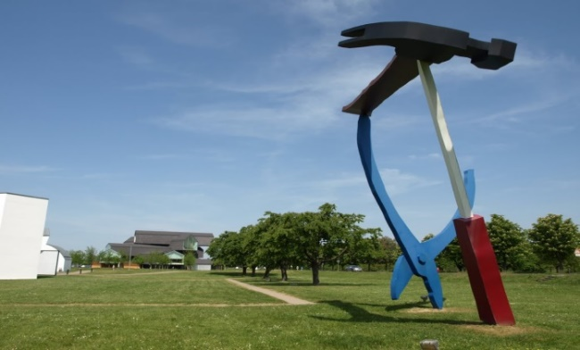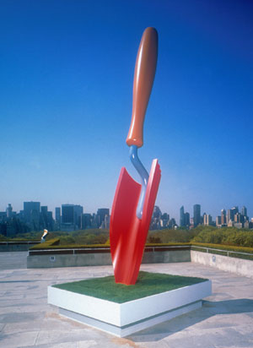
- Wayne Thiebaud, 1963Three Machines
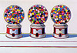
- Andy Warhol, Campbell's Soup I, 1968

Cubism
Origin:
Cubism was one of the most influential visual art styles of the early twentieth century. It was created by Pablo Picasso (Spanish, 1881–1973) and Georges Braque (French, 1882–1963) in Paris between 1907 and 1914. The French art critic Louis Vauxcelles coined the term Cubism after seeing the landscapes Braque had painted in 1908 at L'Estaque in emulation of Cézanne. Vauxcelles called the geometric forms in the highly abstracted works "cubes." Other influences on early Cubism have been linked to Primitivism and non-Western sources.
Design Details
The assertion that the Cubist depiction of space, mass, time, and volume supports (rather than contradicts) the flatness of the canvas was made by Daniel-Henry Kahnweiler as early as 1920, but it was subject to criticism in the 1950s and 1960s, especially by Clement Greenberg, Contemporary views of Cubism are complex, formed to some extent in response to the "Salle 41" Cubists, whose methods were too distinct from those of Picasso and Braque to be considered merely secondary to them. Other interpretations of Cubism have therefore developed. Wider views of Cubism include artists who were later associated with the "Salle 41" artists, e.g., Francis Picabia; the brothers Jacques Villon, Raymond Duchamp-Villon and Marcel Duchamp, who beginning in late 1911 formed the core of the Section d'Or (or the Puteaux Group); the sculptors Alexander Archipenko, Joseph Csaky and Ossip Zadkine as well as Jacques Lipchitz and Henri Laurens; and painters such as Louis Marcoussis, Roger de La Fresnaye, František Kupka, Diego Rivera, Léopold Survage, Auguste Herbin, André Lhote, Gino Severini (after 1916), María Blanchard (after 1916) and Georges Valmier (after 1918). More fundamentally, Christopher Green argues that Douglas Cooper's terms were "later undermined by interpretations of the work of Picasso, Braque, Gris and Léger that stress iconographic and ideological questions rather than methods of representation.
Architectural Details
Architectural interest in Cubism centered on the dissolution and reconstitution of three-dimensional form, using simple geometric shapes, juxtaposed without the illusions of classical perspective. Diverse elements could be superimposed, made transparent or penetrate one another, while retaining their spatial relationships. Cubism had become an influential factor in the development of modern architecture from 1912 (La Maison Cubiste, by Raymond Duchamp-Villon and André Mare) onwards, developing in parallel with architects such as Peter Behrens and Walter Gropius, with the simplification of building design, the use of materials appropriate to industrial production, and the increased use of glass.
The Cubo-Futurist ideas of Filippo Tommaso Marinetti influenced attitudes in avant-garde architecture. The influential De Stijl movement embraced the aesthetic principles of Neo-plasticism developed byPiet Mondrian under the influence of Cubism in Paris. De Stijl was also linked by Gino Severini to Cubist theory through the writings of Albert Gleizes. However, the linking of basic geometric forms with inherent beauty and ease of industrial application—which had been prefigured by Marcel Duchamp from 1914—was left to the founders ofPurism, Amédée Ozenfant and Charles-Édouard Jeanneret (better known as Le Corbusier,) who exhibited paintings together in Paris and published Après le cubisme in 1918. Le Corbusier's ambition had been to translate the properties of his own style of Cubism to architecture. Between 1918 and 1922, Le Corbusier concentrated his efforts on Purist theory and painting. In 1922, Le Corbusier and his cousin Jeanneret opened a studio in Paris at 35 rue de Sèvres. His theoretical studies soon advanced into many different architectural projects.
In the 20th century, Georges Braque and Pablo Picasso began to collaborate and ultimately revolutionize an avant garde art movement that was eventually known as Cubism.
In cubist works, objects are broken up, (visually and/or physically,) reevaluated and reassembled in a more abstract arrangement. The artist represents the subject from a multitude of perspectives in an exaggerated concept. Planes, (surfaces,) meet and clash at unexpected intersections.
Much to the disappointment of the artists’ many critics, a sense of uninterrupted movement is missing from the pieces. As a rejoinder to all the disagreement, it was argued that there is greater value and meaning in the reassignment of objects and shapes. Basically, coherence gives way to interest and reinterpretation.
This unconventional movement changed painting and sculpture, and influenced movements in architecture, literature and music.
Sculpture
Just as in painting, Cubist sculpture is rooted in Paul Cézanne's reduction of painted objects into component planes and geometric solids (cubes, spheres, cylinders, and cones). And just as in painting, it became a pervasive influence and contributed fundamentally to Constructivism and Futurism.

Cubist sculpture developed in parallel to Cubist painting. During the autumn of 1909 Picasso sculpted Head of a Woman (Fernande) with positive features depicted by negative space and vice versa.
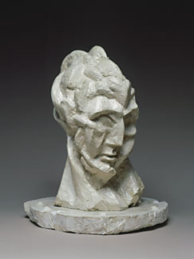
According to Douglas Cooper: "The first true Cubist sculpture was Picasso's impressive Woman's Head, modeled in 1909-10, a counterpart in three dimensions to many similar analytical and faceted heads in his paintings at the time. These positive/negative reversals were ambitiously exploited by Alexander Archipenko in 1912–13, for example in Woman Walking. Joseph Csaky, after Archipenko, was the first sculptor in Paris to join the Cubists, with whom he exhibited from 1911 onwards. They were followed by Raymond Duchamp-Villon and then in 1914 by Jacques Lipchitz, Henri Laurens and Ossip Zadkine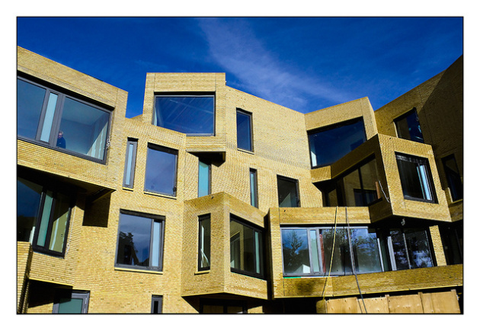 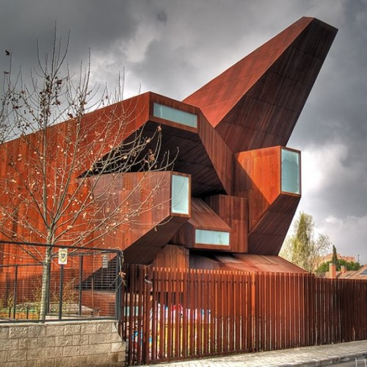

Impressionism

Origin:
Impressionism is a 19th-century art movement that originated with a group of Paris-based artists. Their independent exhibitions brought them to prominence during the 1870s and 1880s, in spite of harsh opposition from the conventional art community in France. The name of the style derives from the title of a Claude Monet work, Impression, soleil levant (Impression, Sunrise), which provoked the critic Louis Leroy to coin the term in a satirical review published in the Parisian newspaper Le Charivari.
Impressionist painting characteristics include relatively small, thin, yet visible brush strokes, open composition, emphasis on accurate depiction of light in its changing qualities (often accentuating the effects of the passage of time), and ordinary subject matter, presence of movement as a crucial element of human perception and experience, and unusual visual angles. The development of Impressionism in the visual arts was soon followed by similar styles in other media that became known as impressionist music and impressionist literature.
Design Details
A number of identifiable techniques and working habits contributed to the innovative style of the Impressionists. Although these methods had been used by previous artists—and are often conspicuous in the work of artists such as Frans Hals, Diego Velázquez,Peter Paul Rubens, John Constable, and J. M. W. Turner—the Impressionists were the first to use them all together, and with such consistency. These techniques include:
- Short, thick strokes of paint quickly capture the essence of the subject, rather than its details. The paint is often applied impasto.
- Colours are applied side-by-side with as little mixing as possible, a technique that exploits the principle of simultaneous contrast to make the colour appear more vivid to the viewer.
- Grays and dark tones are produced by mixing complementary colours. Pure impressionism avoids the use of black paint.
- Wet paint is placed into wet paint without waiting for successive applications to dry, producing softer edges and intermingling of colour.

Sculpture
The sculptor Auguste Rodin is sometimes called an Impressionist for the way he used roughly modeled surfaces to suggest temporary light effects.
Pictorialist photographers whose work is characterized by soft focus and atmospheric effects have also been called Impressionists.
French Impressionist Cinema is a term applied to a loosely defined group of films and filmmakers in France from 1919–1929, although these years are debatable. French Impressionist filmmakers include Abel Gance, Jean Epstein, Germaine Dulac, Marcel L’Herbier, Louis Delluc, and Dmitry Kirsanoff.

Painting
From the 1880s several artists began to develop different precepts for the use of colour, pattern, form, and line, derived from the Impressionist example: Vincent van Gogh, Paul Gauguin,Georges Seurat, and Henri de Toulouse-Lautrec. These artists were slightly younger than the Impressionists, and their work is known as post-Impressionism. Some of the original Impressionist artists also ventured into this new territory; Camille Pissarro briefly painted in a pointillist manner, and even Monet abandoned strict plein air painting. Paul Cézanne, who participated in the first and third Impressionist exhibitions, developed a highly individual vision emphasizing pictorial structure, and he is more often called a post-Impressionist. Although these cases illustrate the difficulty of assigning labels, the work of the original Impressionist painters may, by definition, be categorised as Impressionism.

REALISM

Origin
Realism (or naturalism) in the arts is the attempt “to represent subject matter truthfully, without artificiality and avoiding artistic conventions, implausible, exotic and supernatural elements”.
Realism has been prevalent in the arts at many periods, and is in large part a matter of technique and training, and the avoidance of stylization. In the visual arts, illusionistic realism is the accurate depiction of lifeforms, perspective, and the details of light and colour. Realist works of art may emphasize the ugly or disgusting, such as works of social realism, regionalism, or Kitchen sink realism.
There have been various realism movements in the arts, such as the opera style of verismo, literary realism, theatrical realism and Italian neorealist cinema. The realism art movement in painting began in France in the 1850s, after the 1848 Revolution. The realist painters rejected Romanticism, which had come to dominate French literature and art, with roots in the late 18th century.

Design Details
Realism or naturalism as a style meaning the honest, unidealizing depiction of the subject, can of course be used in depicting any type of subject, without any commitment to treating the typical or everyday. Despite the general idealism of classical art, this too had classical precedents, which came in useful when defending such treatments in the Renaissance and Baroque.
Demetrius of Alopece was a 4th-century BCE sculptor whose work (all now lost) was said to prefer realism over ideal beauty, and during the Ancient Roman Republic even politicians preferred a truthful depiction in portraits, though the early emperors favoured Greek idealism. Goya's portraits of the Spanish royal family represent a sort of peak in the honest and downright unflattering portrayal of important persons.

Sculpture and Painting
A recurring trend in Christian art was "realism" that emphasized the humanity of religious figures, above all Christ and his physical sufferings in his Passion. Following trends in devotional literature, this developed in the Late Middle Ages, where some painted wooden sculptures in particular strayed into the weird in portraying Christ covered in wounds and blood, with the intention of stimulating the viewer to meditate on the suffering that Christ had undergone on his behalf. These were especially found in Germany and Central Europe.
Renaissance theorists opened a debate, which was to last several centuries, as to the correct balance between drawing art from the observation of nature and from idealized forms, typically those found in classical models, or the work of other artists generally. All admitted the importance of the natural, but many believed it should be idealized to various degrees to include only the beautiful.
Leonardo da Vinci was one who championed the pure study of nature, and wished to depict the whole range of individual varieties of forms in the human figure and other things.
Leon Battista Alberti was an early idealizer, stressing the typical, with others such as Michelangelo supporting selection of the most beautiful - he refused to make portraits for that reason.

